JUnit_Basic Testing Exercises

## Exercise 1: Setting Up JUnit Step 1: Create a New Maven Project

1) Open Eclipse.  
2) Go to File > New > Project…  
3) In the wizard, expand Maven, and select Maven Project.

**Step 2: Add JUnit Dependency**

1) In **Project Explorer**, expand your project.  
2️)Double-click **pom.xml** to open it.  
3️)Inside <dependencies>, paste this block:

<dependency>

<groupId>junit</groupId>

<artifactId>junit</artifactId>

<version>4.13.2</version>

<scope>test</scope>

</dependency>

**Step 3: Create a New Test Class**under **src/test/java.**  
  
**Name:** CalculatorTest

**Code :**

import org.junit.Test;

import static org.junit.Assert.assertEquals;

public class CalculatorTest {

@Test

public void testAddition() {

int result = 2 + 3;

assertEquals(5, result);

}

}

**RESULT :**

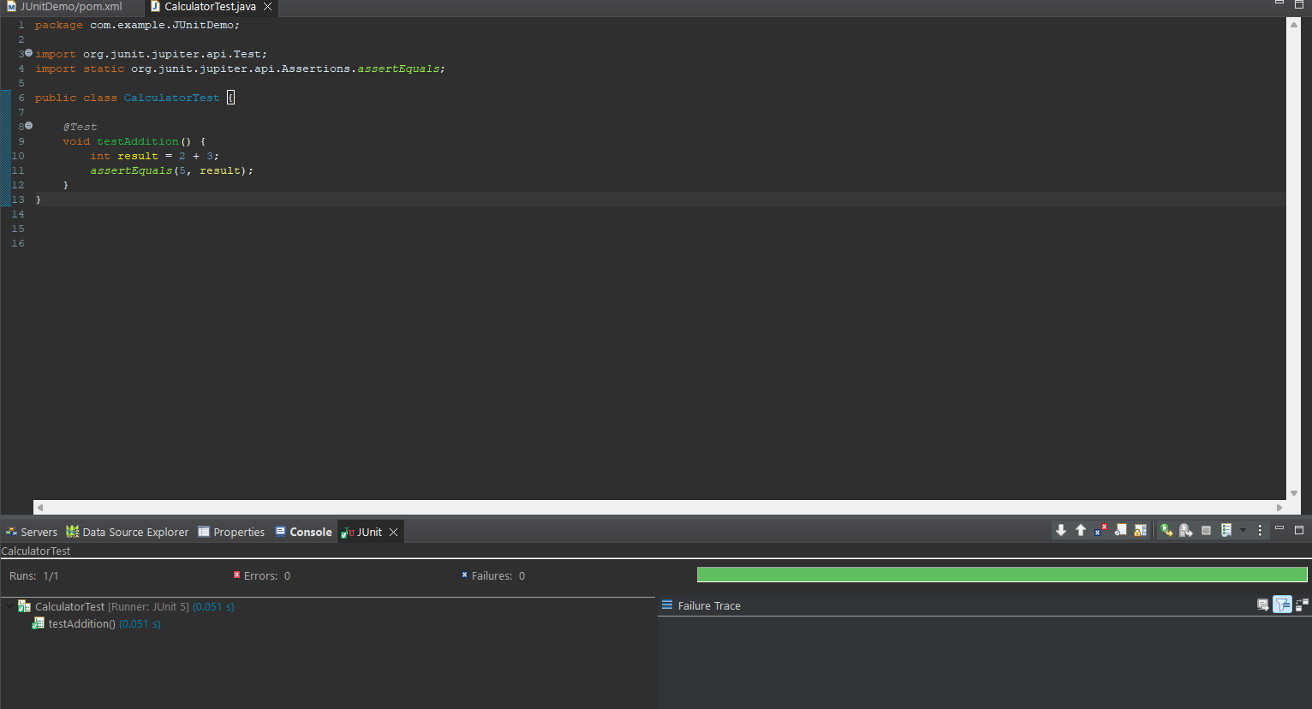

## Exercise 3: Assertions in JUnit Step 1: Create a New Maven Project

1) Open Eclipse.  
2) Go to File > New > Project…  
3) In the wizard, expand Maven, and select Maven Project.

**Step 2: Add JUnit Dependency**

1) In **Project Explorer**, expand your project.  
2️)Double-click **pom.xml** to open it.  
3️)Inside <dependencies>, paste this block:

<dependency>

<groupId>junit</groupId>

<artifactId>junit</artifactId>

<version>4.13.2</version>

<scope>test</scope>

</dependency>

**Step 3: Create a New Test Class**under **src/test/java.**  
  
**Name:** AssertionsTest

**Code :**

package com.example.JUnitDemo;

import org.junit.jupiter.api.Test;

import static org.junit.jupiter.api.Assertions.*;

public class AssertionsTest {

@Test

void testAssertions() {

// Assert equals

assertEquals(5, 2 + 3);

// Assert true

assertTrue(5 > 3);

// Assert false

assertFalse(5 < 3);

// Assert null

assertNull(null);

// Assert not null

assertNotNull(new Object());

}

}

**RESULT :**

